参考链接：
http://vi.vipr.ebaydesc.com/ws/eBayISAPI.dll?ViewItemDescV4&item=262196737906&t=1544694005000&tid=310&category=93631&seller=radiator_shop&excSoj=1&excTrk=1&lsite=3&ittenable=false&domain=ebay.co.uk&descgauge=1&cspheader=1&oneClk=1&secureDesc=0

15Years换成UK Stock

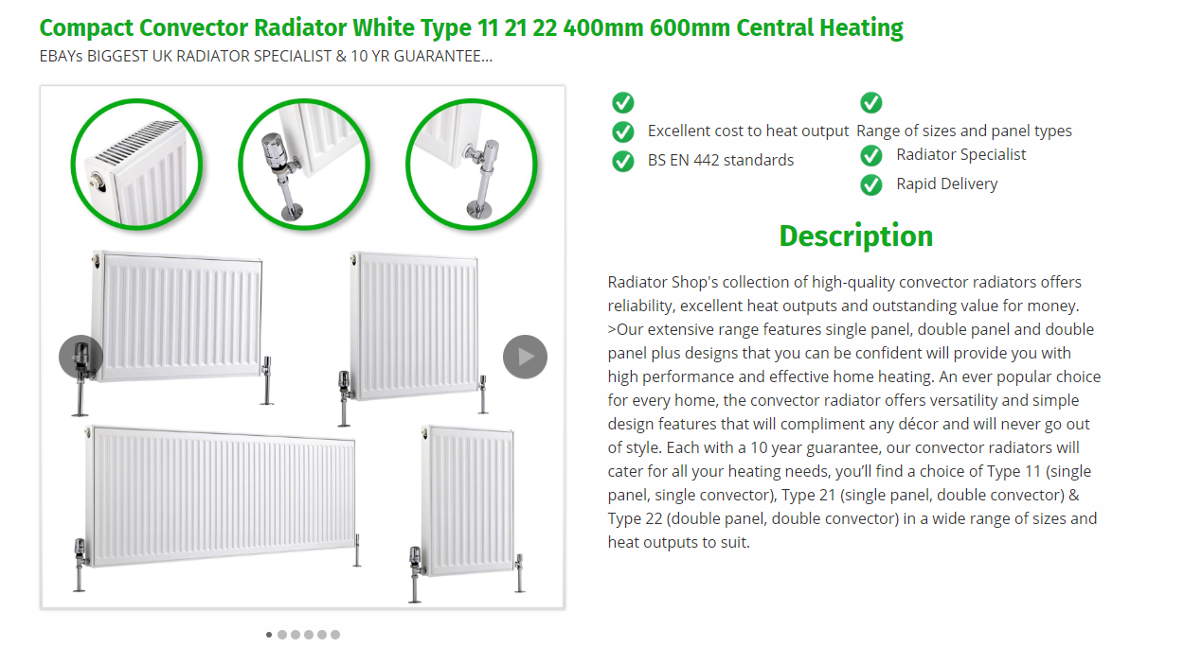
删掉

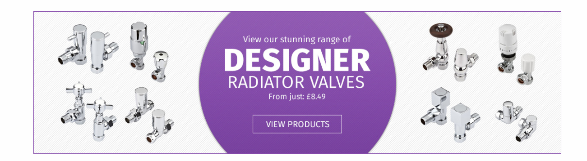
正常广告banner
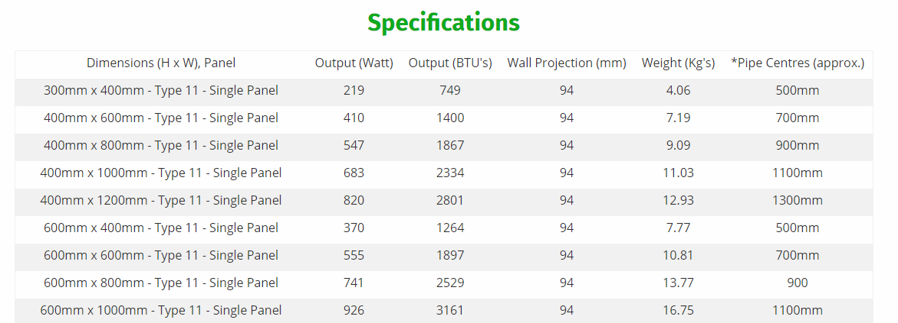
保留一个框架就可以了

